MEMS 1043
Senior Design
Fall 2025

Milestone I

Project Plan

Sponsor

Dr. Ian Sigal
(Ian.sigal@gmail.com)

Team Members and Roles

Coordinator Karan Choudhari kac518@pitt.edu
Planner James Puzon tjp79@pitt.edu
Resource Manager Logan Radomicki clr107@pitt.edu
Resource Manager Lowell Shaw lhs26@pitt.edu
Presenter Max Mongiello mjm459@pitt.edu

1. Project Background

Summary of Need

Our project will attempt to address two issues. First, the lack of an automated system to build fiber structures in Dr. Sigal’s Ocular Biomechanics Lab. Second, a desire for stronger & more adaptive fiber implants in the medical industry. To solve both issues, we aim to design a robot capable of creating complex 3D fiber structures with minimal human intervention.
For the Ocular Biomechanics Lab, this will enable them to mimic collagen fiber structures found in the eye. Mechanical testing of these structures will allow them to verify and adjust what they have learned from characterization and digital modeling of the eye. While these structures can be made manually, the number of hours required ensures that it is not an option for the lab. As such, this robot would open an entirely new field of research closely related to their current interests.
Dr. Sigal’s lab believes that they can apply what they learn from ocular fiber structures to create better fiber products in other applications. The field of woven medical implants is one industry that Dr. Sigal has identified, and our literature search agrees that it would benefit extensively from new manufacturing methods. Hernia patches and intervaginal meshes are two specific applications we have identified, both suffering from high rates of recurrence and poor patient outcomes in many cases [1], [2], [3], [4].

Industry Served

Dr. Sigal founded the Laboratory of Ocular Biomechanics in 2010. With a focus on computational modeling and characterization of the eye, his lab has pioneered the use of these tools in explaining how and why glaucoma develops. One such tool used by the lab is instant polarized light microscopy (IPOL). Their research on IPOL for ocular characterization has allowed for distinction of fibers not previously possible, while simultaneously improving speed and reducing cost [5]. Further applications of IPOL have enabled them to explore the nature of ocular collagen structure in greater detail. They found that new 3D simulations based on IPOL results captured complex fiber interactions that 2D models had not accounted for and could not capture [6], [7]. Recently, his lab’s research has also expanded into new techniques for the manufacture of fiber-reinforced composites.
Fiber-woven medical devices are another application that can benefit from Dr. Sigal’s research. Medical textiles are typically produced through fabrication techniques such as braiding, weaving, or knitting; the specific patterns used for each type can result in different strengths and applications. Braiding can be used for rebuilding tendons or ligaments, due to its ability to form hollow tubes. Woven structures are based upon braiding, maintaining strength and durability without any stretching. This allows them to be used in joint and spine applications. Knitting methods use multiple fiber and can be used to produce more complex implants, used in bone replacement. For each of these methods, the layout of the fiber can result in differences in properties such as yield strength, variable density, and biological compatibility. Dr. Sigal’s research into collagen fibers could be used in the development of more effective medical textile applications, resulting in better healthcare for the patient population.
One such application is the hernia patch, a woven mesh implanted during surgery to repair a hernia [2], [4]. Hernias occur in humans when the abdominal muscle wall fails, and internal organs protrude out through the weakened area. When repairing a hernia, the patch is sutured in to serve as a replacement for the muscle wall and allow for eventual recovery of the tissue; if the patch fails or the hernia resurfaces, this is termed “reherniation”. Hernia patches are not a perfect solution: one study found that about half of congenital diaphragmatic hernia (a birth defect resulting in hernia of the diaphragm) patients experienced reherniation within three years [4]. Another study covering hernia repair in adults found that roughly 20% of patients experienced reherniation, and half of these cases were the result of some form of patch failure [2].
While there has been some debate over whether hernia patches are an acceptable device for repairing hernias, other uses of surgical mesh have received far more criticism[3]. The most well-known example of this is the use of transvaginal surgical mesh. This mesh is used to repair tissue in the event of pelvic organ prolapse (protruding or collapse of the uterus, bladder, or rectum) [1]. These meshes have a long list of possible complications, including tissue erosion, pain, perforation, urinary issues, and bleeding [1], [3]. As a result, transvaginal/pelvic meshes were banned in Australia, New Zealand, the UK, and the USA. The manufacturers of these products argued they are critical in treating vaginal prolapse, which effects half of all women over 50 with a history of vaginal childbirth [8]. In their current state, these meshes are clearly not a solution.

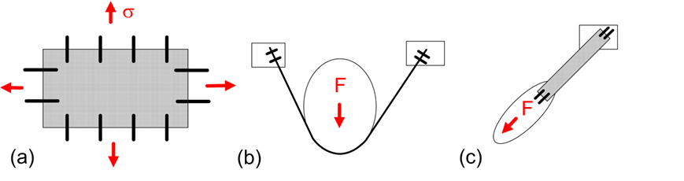
Figure 1. Loading scenarios for (a) Hernia patches and (b,c) pelvic meshes. While hernia patches can be modeled as experiencing simple biaxial tension, pelvic meshes undergo somewhat more complex loading. This may cause additional stress on the mesh or sutures and lead to premature failure. Image Reproduced from Ref. [3]

As illustrated in Figure 1, while pelvic meshes are often made of the same material as hernia patches. However, they differ significantly in what stresses they experience - as illustrated in Figure 1 [2]. Hernia patches are loaded in biaxial tension and can be accurately modeled as part of a pressure vessel. One study identified that the failure rate of these patches depended on the surgeon who implanted them, suggesting that the suture placement affects the stresses on the patch. Dr. Sigal has suggested this could be resolved with a self-balancing patch, which could be produced by mimicking ocular fiber structures. Pelvic meshes experience much more complex and varied loading, which would likely also benefit from the improved strength of a self-balancing fiber structure.

End User
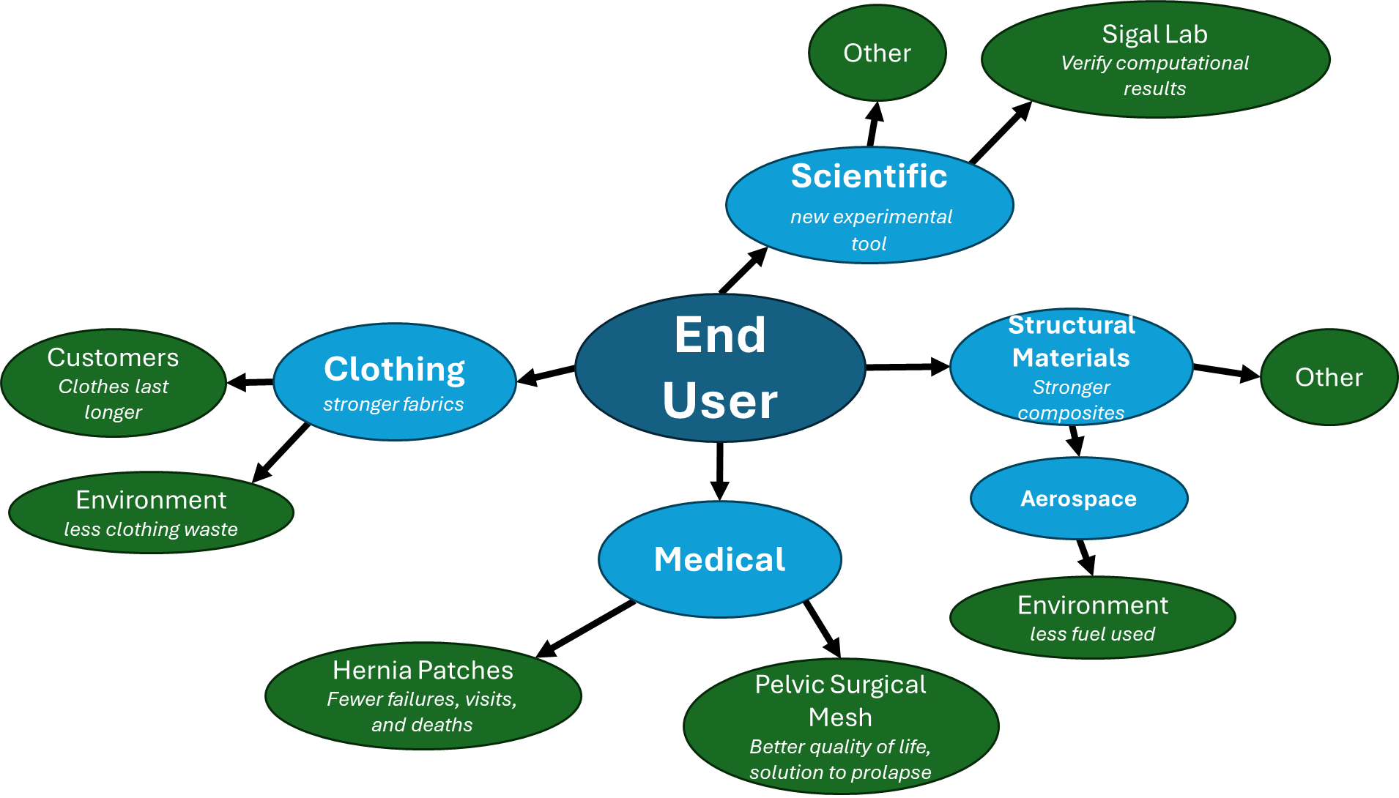
Figure 2. Mind Map used to determine the end user and guide our literature search.

The diagram shown in Figure 2 maps out our thought process used for determining our end user through the literature search step of the design process. Of the industries considered here, we found the strongest argument for the medical field.
While our immediate end users are the researchers working in Dr. Sigal’s lab, we believe that, eventually, the people depending on woven medical devices will benefit the most from this project. As explained in our “Industry Served” section, these critical products too often fail in a way that worsens patient quality of life or causes a serious medical emergency. If successful, our robot would be capable of building self-balancing fiber products that could serve as a much better solution to these issues.

Motivation

As outlined in the ‘Industry Served’ section, the Ocular Biomechanics Lab has built an extensive body of work on modeling and characterization of the eye. Experimentally verifying their claims would be extremely valuable, but there is no way to reproduce ocular fiber structures on-demand. Thus, their initial interest in creating fiber structures was to model collagen fiber mechanics within the eye. From the efforts of previous researchers and design teams, as well as their computational work, they know that 2D structures are not an accurate model of how the eye behaves. A robot capable of manufacturing 3D fiber structures will enable them to compare real-world performance to simulation.
They hope that real-world modeling of ocular fiber structures will allow them to discover stronger configurations for fiber structures, enabling better solutions for fiber-based products. This may include woven medical devices, fiber-reinforced composites, textiles and clothing, or any other industry that uses fibers. If this is possible, the robot’s use will expand to a manufacturing tool used in a wide variety of industries.

Significance and Impact

For Dr. Sigal’s lab, this robot has the chance to improve understanding of glaucoma and the mechanics of the eye. Glaucoma has been estimated to impact 3.5% of the global population; improving our understanding of this disease has the potential to prevent blindness in a huge number of people [9].
The development of better fiber products has similar potential. Better surgical meshes could prevent many hospital visits; in the case of transvaginal meshes, they could prevent chronic pain and improve quality of life for patients. Stronger composites could lighten aircraft, therefore improving efficiency and reducing pollution. More durable clothing could save consumers money and reduce waste through less frequent replacements.

Project Continuation

The previous senior design team designed a passive end effector for dispensing fiber under tension and implemented this on a robot arm to build basic fiber structures. This system was incapable of placing fixtures or tying off by itself, limiting its practical use significantly. The robot had issues consistently navigating to a position or holding any significant load, further limiting its use.
The ocular biomechanics lab has purchased a new industrial robot arm which is expected to be much more accurate. This arm is not directly compatible with the previous end effector and does not represent a solution with how much human involvement is required to construct anything but simple structures.
As such, the project should be continued to develop a new end effector capable of starting and ending a fiber, implement the end effector, and program the new robot to build complex 3D fiber structures.

2. Specifications and Requirements

Project Design Constraints

- End effector must mount on a Standard Bots RO1
  - Must weigh less than 18kg
- Must dispense fiber under tension
  - Support fiber without failure (by bending, etc.)
  - Survive abrasion by fiber, and not abrade fiber too much
  - Tension should not be more than the robot or nails can handle
- Challenge: Start and end fiber without human assistance
- Minimize human intervention
- Hold a reasonable amount of fiber, to minimize the number of times it needs to be replaced during operation.
- Not be a danger to people working in the lab
- Be able to create 3D fiber structures
- Needs to be able to fix fiber to a point, and continue the fiber afterwards
- Minimize the size of the end effector tip, to allow for higher-resolution structures
- Be able to reproduce structures reliably (better than 70% success rate, minimum; should be much better)
- Adapt to different structures –should be able to make anything programmable

Requirements & Specifications

Requirements (* indicates that this should eventually have an accompanying spec)
- End effector must mount on a standard bots RO1;
  - Validation: does the end effector does not come off without removal of securing bolts? Can it be removed when desired?
- Must dispense fiber under tension
  - Validation: does string between two points appear as a straight line and is not visibly sagging or bowing?
- Not abrade fiber too much
  - Validation: is fiber visibly damaged? fraying/unwinding)
- Challenge: Start and end fiber without human assistance
  - Validation: Can the robot fix fiber to a starting point? Can it fix fiber to an endpoint and snip the remaining thread? In the event of an error on one fiber, can the robot continue operation building the rest of the structure? Can the robot be left to run overnight or without supervision?
- Hold enough fiber to not require replacement during operation
  - Validation: can the robot complete structures without finishing a spool?
- Not be a danger to people working in the lab
  - Validation: does the robot move only within the intended target area?
- Be able to create 3D fiber structures
  - Validation: can the robot recreate the previous team’s bridge? Can it build some more elaborate structure, currently TBD?
- Needs to be able to fix fiber to a point, and continue the fiber afterwards
  - Validation: can the robot build polygonal chains by attaching fiber to a starting point, winding it between some number of midpoints, and then terminating the fiber?
- Minimize the size of the end effector tip, to allow for higher-resolution structures
  - Validation: is the end effector colliding with nails or already-placed fibers?
- Adapt to different structures –should be able to make anything programmable
  - Validation: does the robot require extensive troubleshooting every time a new structure is tried? It shouldn’t.

Specifications
- End effector must weigh less than 18kg and conform to dimensions of connecting flange
  - Validation: Does the end effector meet requirement #1? How much does it weigh?
- Be able to reliably reproduce structures at a success rate greater than 70%
  - Validation: Measure number of successful vs. failed fibers when producing larger structures and perform statistical analysis.

Summary Mind Map or Quad Chart

Table 1. Quad chart describing requirements & specifications for the fiber-laying robot.
Robot‐Assisted Construction of Fibrous Materials
Quad Chart
Function:  - Build polygonal chains by fixing fiber to points  - Create 3D structures consisting of multiple fibers  - Adapt to different programmable structures  - Continue building structure even after a failed fiber  - Not endanger nearby humans | Specifications:  - Mount end effector to Standard Bots RO1  - Hold enough fiber to operate without spool replacement  - Reproduce structures reliably, with minimal error in fiber placement
Challenges:  - Start and end fiber without human assistance  - Operate overnight without issue | Performance Criteria:  - Dispense fiber under tension to produce straight lines  - Avoid abrasion of fiber, maintaining integrity  - Minimize end effector tip size

3. Project Goal, Objectives and Tasks

Project Goal

Develop an end effector for a new robotic arm that is capable of laying fiber across a three-dimensional structure composed of multiple fiber segments secured to nails, free of human intervention from start to finish. The end effector must be capable of going under already-weaved fiber.

Objectives

Objective 1 – Design a flange capable of connecting an existing end effector, developed by the previous design team, to a new robotic arm and establish control over robotic arm movement. Completion of this objective will allow the new robotic arm to lay down fiber for an existing three-dimensional structure.

Objective 2 – A new end effector will be designed and developed with the following capabilities: passive placement of fiber under tension, weaving under and around existing fibers, and starting/stopping without human intervention. Rapid prototypes will be designed and printed using the Pitt Makerspace, and testing will be done by hand, with final prototype testing being done on the new robotic arm and structure designed in objective 3.

Objective 3 – Develop a new three-dimensional structure that showcases the full range of movement for the new robotic arm, as well as weaving and start-stop capabilities. CAD models of the structures will be developed and programmed into the robotic arm, and the physical structure will be built using the Pitt Makerspace. A miniature test structure will be built for intermediate testing.

Tasks

Objective 1:
- Cad flange
- Print flange
- Test Assembly on robot
- Redesign if needed
- Learn software
- Achieve robot movement
- Achieve wrap-around
- Test existing bridge path

Objective 3:
- Prototype start/stop, weaving
- Brainstorm knot ideas, adapt weaving end effector
- Design New end effector - different string mount, tension stuff
- Print New end effector
- Assemble and test end effector prototype
- Build new prototype (unmounted) to test concept
- Repeat prototyping
- Build final prototype to mount on robot
- Test on new structure

Objective 2:
- Design new base for test structure
- Research potential 3D structures
- Digitally design new structure
- Build final structure and base

Endpoints – Deliverables and Metrics for Success

Our primary deliverables include the mechanical end effector and the thread-based structure created using the robot-effector system. Additional deliverables and metrics for success include the movement script used to control the robot and a recording of the robot successfully creating the structure for use in our design symposium.
Additionally, all 3D models of mechanical components such as the end effector, auto-start-stop system, etc., will be handed over to our sponsor in anticipation of another iteration of this project to follow.

4. Project Planning

Resources

Materials: M6 mechanical fasteners, nails, FDM filament (PLA,PETG), yarn
Hardware: Standard Bots RO1
Software: RoboDK, Python, SolidWorks
Vendors: Swanson Center for Product Innovation (SCPI), Pitt Makerspace, McMaster-Carr, Wawak Sewing Supplies (or similar - for fiber tensioning hardware)

Anticipated Design Iterations

The first major design element is an end-effector for the Standard Bots RO1. To start, we will use the previously designed end-effector and design a flange that will connect it to the new robot. This will allow our team’s design to be modular, and we can easily attach new iterations of the end-effector to the flange. For the flange, future iterations may be necessary to increase the strength of the connection, but designing this separately from the end-effector allows for more flexibility in the future.
The second major design element is a new end-effector with the ability to start and stop fibers by securing starting/ending points and terminating the thread. Many different iterations will be necessary to test the different methods of starting and stopping; the modularity of the flange will support this.
The last major design element is a test structure for the laying of the fibers. We anticipate having two test structures; the first will be a bridge that demonstrates the load bearing capacity of the fibers, and the second will be a structure that relates our project to the ocular research done by Dr. Sigal. The complexity of the second structure will be determined by the outcome of the bridge testing.

Support from Project Sponsor

Previous design models and prototypes from predecessors on our project path would be excellent sources of inspiration for the development of effective systems which satisfy our sponsor’s requirements. As a result, support from our sponsor in the form of supplying these digital materials for review will greatly benefit our project. Our sponsor, being a subject matter expert in fiber mechanics, will also aid in our development efforts.
Our sponsor’s lab has already developed a prototype end effector that can weave fibers, which may be useful in our design of an end-effector that can tie a knot. Design files and operating principles will be useful as a reference.
Lastly, our sponsor’s experience as the principal investigator of a large research group makes him an excellent resource in brainstorming, discussing, and selecting ideas to be used in our prototypes and final design.

Support from Swanson Center for Product Innovation

We anticipate that our prototypes will be fabricated using FDM printing. As such, we do not currently expect to need any support from SCPI in machining metal parts.

Support from Subject Matter Experts

Dr. Styler and Dr. Clark teach the intro to robotics course at Pitt and will be useful in providing our team ideas and guidance. Dr. Sigal’s expertise in fiber mechanics will support our development of final test structures.

Potential Risks and Anticipated Failures

Risk: not being able to design an end-effector to tie a knot
Workaround: use an alternative to a nail that is easy to attach string to with a passive end-effector

Milestones

- Successfully complete a test run with the robot by achieving what the previous group did, but with the new robot arm.
- Achieve the start/stop function
- Build a model to be presented at the design expo

Budget:

Our project’s budget does not anticipate exceeding the $250 standard set by the department, and our current estimated costs as of publishing this document fall under $100. Current anticipated costs include 4 M6 mechanical fasteners used to mount the end effector on the robot arm. Potential costs include small electric motors used to generate independent moving components which may be considered in the auto-start-stop system as well as the cost of supports and components which will comprise the base of the threaded structure.

Timeline

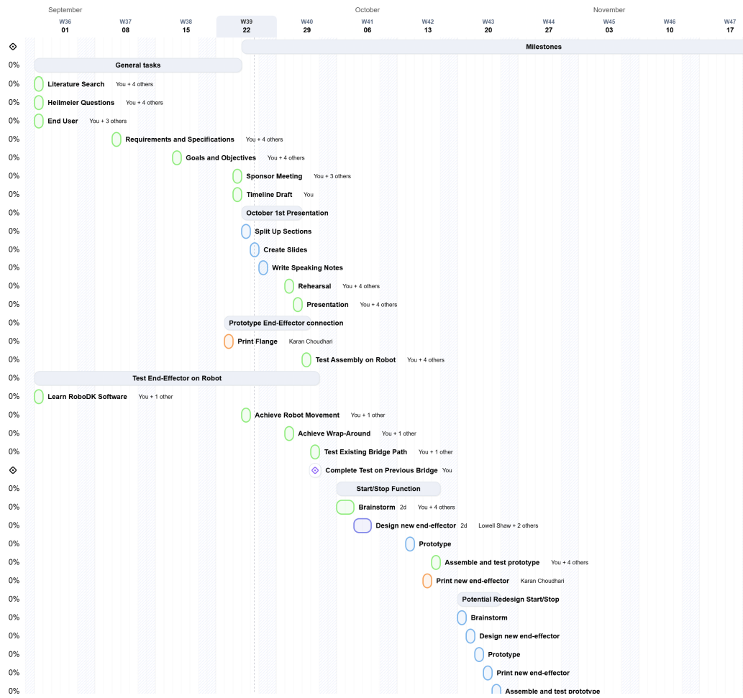[continued on next page]


5. Project Execution

Analysis & Design

To determine what potential new aspects of the end effector the team was expected to build, meetings between the team and the sponsor, Dr. Sigal, were held. Analysis techniques learned in ENGR 0011 were used to formulate questions that specifically identified user needs. This allowed identification of start/stop and weaving capability as the two most important objectives.
To fuel the team’s initial ideation, methods from MEMS 0024 will be used to develop unique and non-obvious solutions. The gallery method will allow for each team member to present their own ideas, and use of design heuristics will promote out-of-the-box thinking. The CAD skills learned in this class will also be critical for prototyping.
Design of the robot’s programming will require experience with robot operating systems. Careful use of forward & inverse kinematics will also be required to ensure the robot moves as expected. These topics are covered in MEMS 1097, which will prove critical in the completion of this project.
The failure analysis approaches covered in MEMS 1028 will be used to analyze the potential stresses on each component of the end effector. This analysis will be used in the design and dimensioning of the parts to ensure unexpected failure is avoided. Since the robot used by our team is much stronger than the one used by the previous team, this is important to consider.
Lastly, the materials selection approach outlined in MEMS 1030 will be used to determine what materials should be used to manufacture the end effector. Considering the low-impact operating environment and minimal expected stress, this will not be critical. However, if not considered, our end effector may fail unexpectedly or have issues with long-term use.

Verification

Objective 1 – Verification of this step will be success in programming the new robotic arm to weave fabric around the existing bridge structure used for previous projects, while using the existing end effector. This establishes control over the new robotic arm, prompting the team to start developing a new structure.
Objective 2 – Verification of this step will be a CAD Model of a new three-dimensional structure, that can be used by the robot to map out a path for the end effector. A physical model will also be created at the end of this objective, used for final testing.
Objective 3 – Verification of this step will include an end effector capable of passing fabric under previously weaved fabric, as well as starting and stopping building the full three-dimensional structure with no human intervention, with a success rate of over 90%.

6. Project Organization

Team Meetings

Team meetings will take place at the Benedum library on Tuesdays and Thursdays, as well as after classes if needed. The team will meet at least twice a week. The presenter role (Max) is responsible for recording visual information and note taking will be done by Lowell.

Work Space

Appropriate workspaces for us include the Benedum library, Benedum makerspace rooms, and the Senior design room. The robot itself will be stored at Dr. Segal’s lab, while end effectors and other smaller parts will be stored in the senior design room or with team members if that room is not available. Software and other documents will be stored on the Teamwork website given by the professor for our use.

Sponsor Meetings

Sponsor meetings are in-person and take place at least once per week on Thursdays or Fridays, depending on which team members need to meet.

Sharing, Distribution and Archival of Project Data

Software and other documents will be stored on the teamwork project board designated for us to use by Dr. Schmidt.

Return of Equipment

We do not plan on any equipment sent by the lab needing to be returned since the robot itself is very large and not easy to move around (it will never leave the lab). However, in the case of equipment needing to be returned communication with the organization will be conducted by the communicator role (Karan).

7. Project Outcomes

Community

The community benefited by this project is bipartite, as outlined in our background section. Dr. Sigal’s lab will immediately benefit from our project’s completion, as the robot will open a new research area: physical simulation of ocular biomechanics. With the knowledge gained from this research, they hope to support the development of new fiber products. We believe the most beneficial of these products would be improved surgical meshes, such as those used in hernia or pelvic prolapse repair. Improvement of these products will improve surgical outcomes and quality of life for the patients who require them.

Educational

We believe this project is unique in that we are not just implementing an existing solution or working a problem but developing a system to accomplish something no known commercial or research supplier is capable of. There is no existing robot that can build the structures the Ocular Biomechanics Lab needs. Working towards an open-ended and uncertain solution is an invaluable experience; it will also improve our skills in communication, adaptability, and self-sufficiency.

We also hope to learn numerous ‘hard’ and ‘soft’ skills that are beneficial in future working environments. Primary skills include establishing and following a timeline, while being prepared to adapt to failures and surprises. As we build our prototype, we expect to learn how to troubleshoot while rapid prototyping, and how to prioritize certain aspects over others. We expect to develop our ability to work effectively in a team environment while managing our individual responsibilities. We hope that our exposure to Dr. Sigal’s lab will give us introductory knowledge of fiber mechanics within the eye. Working with the robot arm will significantly improve our knowledge of robotic systems and programming, a field that is notoriously hard to gain experience in.

8. Works Cited

[1] “FDA orders transvaginal surgical mesh pulled from market | Reuters.” Accessed: Sep. 20, 2025. [Online]. Available: https://www.reuters.com/article/us-fda-surgicalmesh/fda-orders-transvaginal-surgical-mesh-pulled-from-market-idUSKCN1RS1QN/
[2] J. A. Warren, S. P. McGrath, A. L. Hale, J. A. Ewing, A. M. Carbonell, and W. S. Cobb, “Patterns of Recurrence and Mechanisms of Failure after Open Ventral Hernia Repair with Mesh,” Am Surg, vol. 83, no. 11, pp. 1275–1282, Nov. 2017, doi: 10.1177/000313481708301131.
[3] D. Taylor, “The failure of polypropylene surgical mesh in vivo,” J Mech Behav Biomed Mater, vol. 88, pp. 370–376, Dec. 2018, doi: 10.1016/J.JMBBM.2018.08.041.
[4] R. L. Moss, C. M. Chen, and M. R. Harrison, “Prosthetic patch durability in congenital diaphragmatic hernia: A long-term follow-up study,” J Pediatr Surg, vol. 36, no. 1, pp. 152–154, Jan. 2001, doi: 10.1053/JPSU.2001.20037.
[5] P. Y. Lee, H. Schilpp, N. Naylor, S. C. Watkins, B. Yang, and I. A. Sigal, “Instant polarized light microscopy pi (IPOLπ) for quantitative imaging of collagen architecture and dynamics in ocular tissues,” Opt Lasers Eng, vol. 166, Jul. 2023, doi: 10.1016/J.OPTLASENG.2023.107594.
[6] M. R. Islam, F. Ji, M. Bansal, Y. Hua, and I. A. Sigal, “Fibrous finite element modeling of the optic nerve head region,” Acta Biomater, vol. 175, p. 123, Feb. 2023, doi: 10.1016/J.ACTBIO.2023.12.034.
[7] F. Ji, M. Quinn, Y. Hua, P. Y. Lee, and I. A. Sigal, “2D or not 2D? Mapping the in-depth inclination of the collagen fibers of the corneoscleral shell,” Exp Eye Res, vol. 237, Dec. 2023, doi: 10.1016/J.EXER.2023.109701.
[8] S. Todros, P. G. Pavan, and A. N. Natali, “Biomechanical properties of synthetic surgical meshes for pelvic prolapse repair,” J Mech Behav Biomed Mater, vol. 55, pp. 271–285, Mar. 2016, doi: 10.1016/J.JMBBM.2015.10.024.
[9] Y. C. Tham, X. Li, T. Y. Wong, H. A. Quigley, T. Aung, and C. Y. Cheng, “Global Prevalence of Glaucoma and Projections of Glaucoma Burden through 2040: A Systematic Review and Meta-Analysis,” Ophthalmology, vol. 121, no. 11, pp. 2081–2090, Nov. 2014, doi: 10.1016/J.OPHTHA.2014.05.013.

